**17MIS1139**

**S.SOWMIYA**

**LAB - 6**

**1) System calls for file open,read,write**

**Code:**

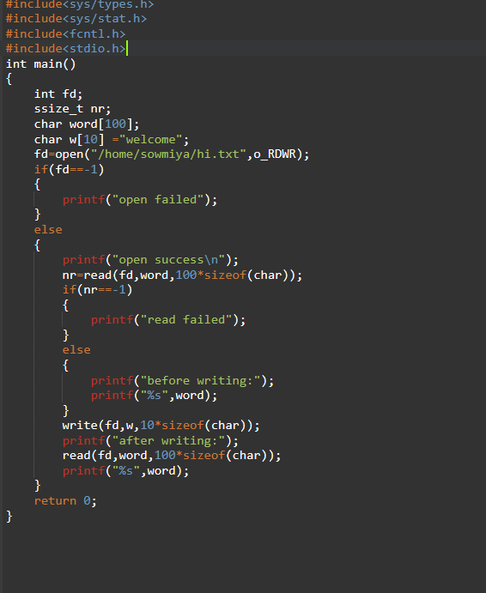

**Output:**

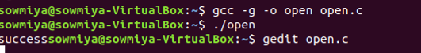

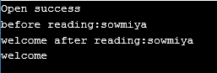

**2) Manage EINTR while accessing file using system calls.**

**Code:**

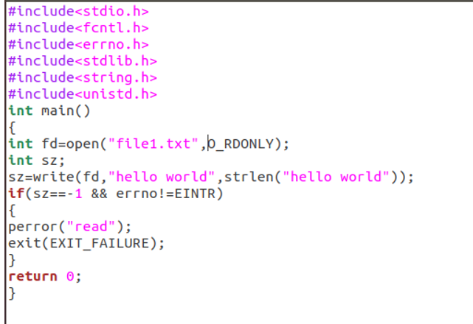

Output:



**3) Do Non-Block read and write using system calls.**

**Code:**

#include<sys/types.h>

#include<sys/stat.h>

#include<fcntl.h>

#include<stdio.h>

#include<errno.h>

int main()

{

int fd,errno,len;

ssize_t ret;

char word[100];

char w[100]="srihari";

ssize_t nr;

fd=open("/home/eg1/read.txt",O_RDWR);

if(fd==-1)

{

fprintf(stdout,"failed");

}else

{

fprintf(stdout,"success");

nr=read(fd,word,100*sizeof(char));

if(nr==-1)

{

fprintf(stdout,"read failed");

}else

{

fprintf(stdout,word);

len=sizeof(char);

char *buff;

while(len!=0 && (ret=read(fd,buff,len ))!=0)

{

if(ret==-1)

{

if(errno==EINTR)

continue;

perror("read");

break;

}

len=len-ret;

buff+=ret;

}

}

}

}

**Output:**

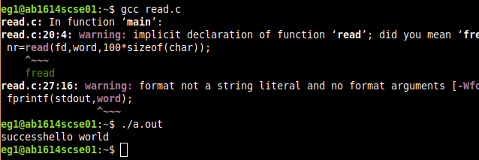

**4) Disable Write permissions to user for all the files in specific folder.**

**1. Shell script to remove write access to all the files**

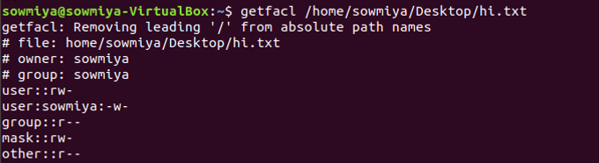

**setting read,write and executable permission**

**code:**

chmod +rwx $HOME/Desktop/sowmiya/hi.txt

echo "file permissions set"

**Output:**



**removing file permissions using chmod:**

**code:**

chmod -rwx $HOME/Desktop/sowmiya/hi.txt

echo "file permissions removed"

**Output:**



**2. Set write permission to only one user on the file**

**Code:**

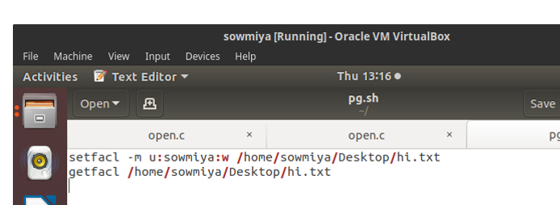

**Output:**

